PRACTICAL 6
Research Question:
"To what extent do AI-powered coding assistants improve developer productivity, and what are the associated security risks when these tools are used during the implementation phase of the software development life cycle (SDLC)?"
Search String:
("AI coding assistant" OR "GitHub Copilot" OR "LLM code generation") AND ("developer productivity" OR "efficiency") AND ("code security" OR "vulnerabilities" OR "software bugs")
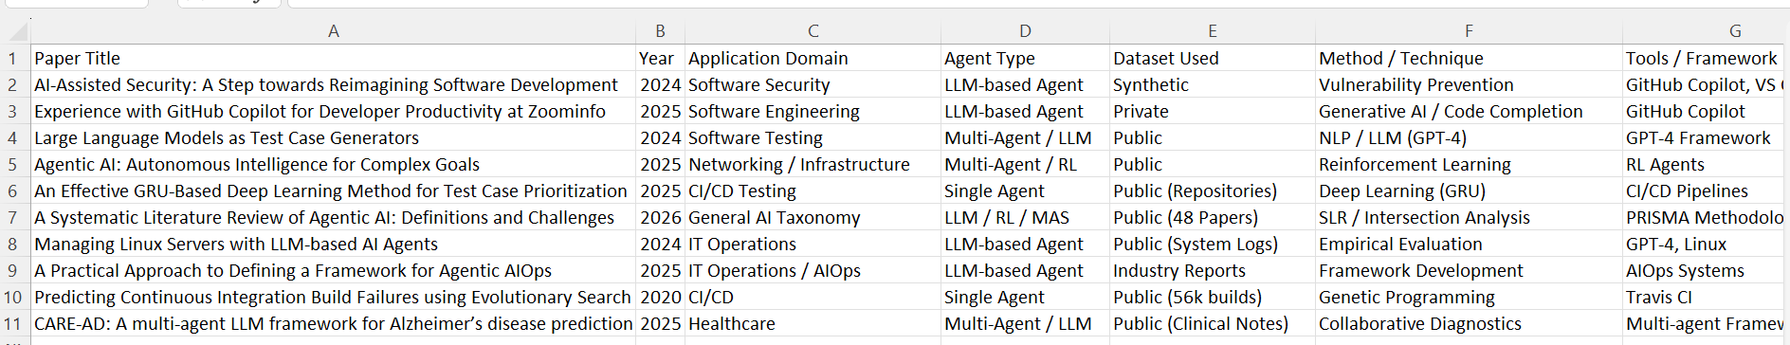
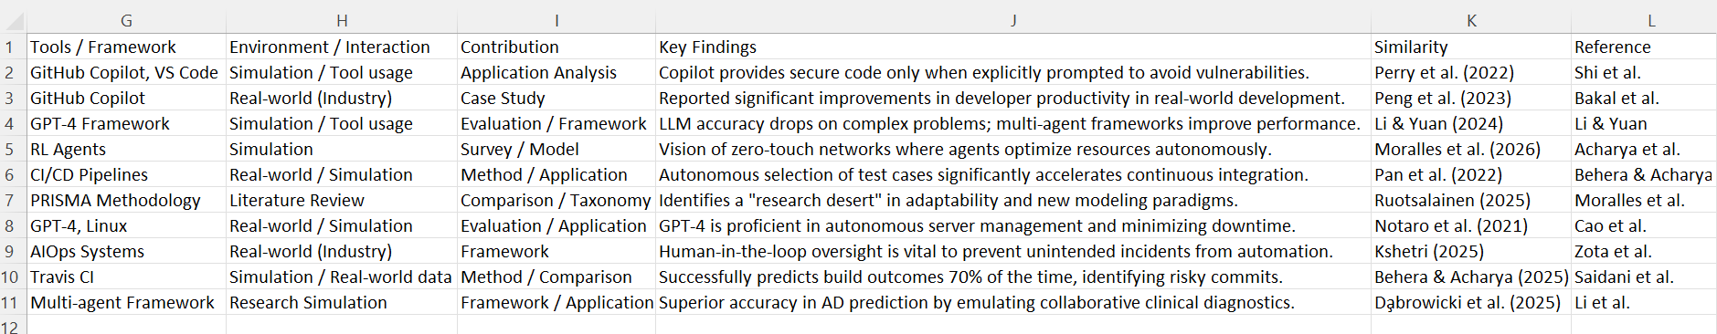
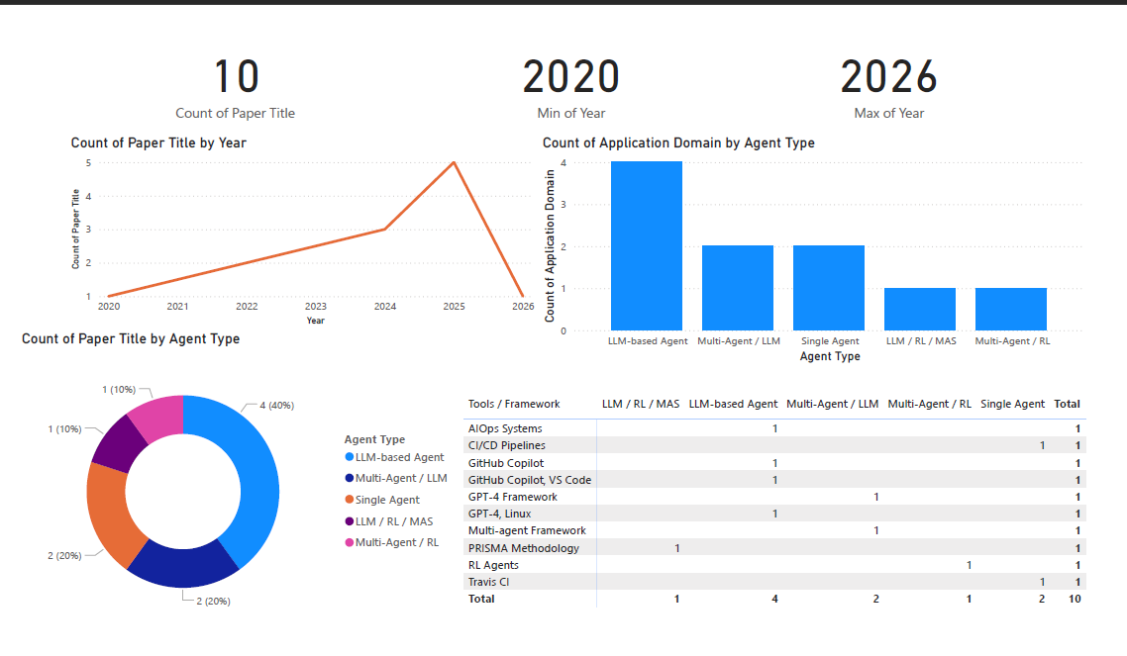

RESEARCH GAP:
There is a significant research gap in developing robust agentic systems that can operate effectively across the entire software development life cycle. Current architectures lack long-term adaptability, making it difficult for agents to dynamically adjust their behavior in unpredictable or volatile environments. While AI-driven solutions such as AIOps are well-developed for operational stages, the early phases of design and coding remain underexplored, with existing tools functioning primarily as passive assistants rather than proactive, autonomous agents. Additionally, AI implementations are often siloed within specific stages of the life cycle, lacking integrated feedback loops that can transfer insights from operations back to development and testing. Evaluation methods also remain outdated, as they focus on static accuracy instead of measuring critical aspects like proactivity, resilience, and recovery from errors. Furthermore, there are growing concerns around trust and security, as AI-generated outputs may include insecure coding practices unless explicitly guided otherwise. Finally, progress in this domain is constrained by limited data sharing and the substantial computational resources required to scale agentic systems effectively across all stages.

